Stem Cell Treatments: New Breakthroughs In Leukemia, Liver Cancer, And Diabetes
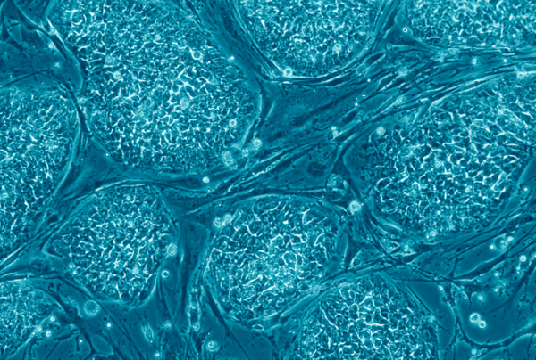

Stem cells could be used to treat leukemia. liver cancer, and diabetes. (Photo : Wikimedia Commons)

Styem cell treatments have been a hot topic lately, and researchers have found a number of conditions that could benefit from this technique.
An investigational personalized cellular therapy put 90 percent of children and adults with acute lymphoblastic leukemia (ALL) into remission, many of these individuals had suffered several relapses in the past or failed to respond to common treatments.
In a trial encompassing 30 patients, 27 achieved complete remission after receiving engineered "hunter" cells dubbed CTL019, the Perelman School of Medicine at the University of Pennsylvania reported. Seventy-eight percent of the participants were still alive six months after receiving the treatment.
"The patients who participated in these trials had relapsed as many as four times, including 60 percent whose cancers came back even after stem cell transplants. Their cancers were so aggressive they had no treatment options left," said the study's senior author, Stephan Grupp, a professor of Pediatrics in Penn's Perelman School of Medicine and director of Translational Research in the Center for Childhood Cancer Research at the Children's Hospital of Philadelphia. "The durable responses we have observed with CTL019 therapy are unprecedented."
CTL019 is manufactured using the patient's own T cells, which are then reprogrammed with a gene transfer technique that teaches them to target and kill tumor cells. The engineered T cells contain an antibody-like protein called a chimeric antigen receptor (CAR), which binds to a protein called CD19 found on the surface of cancerous B cells. These modified cells are then transferred back into the patient's body where they attack intruding cancer cells.
Nineteen of the patients who were treated in the study are still in remission, 15 of which were treated exclusively with this novel technique. One of these patients is a 9-year-old boy who was the first to be treated with personalized cellular therapy over two years ago.
"Our results support that CTL019 can produce long-lasting remissions for certain heavily pre-treated ALL patients without further therapy. For our patients who have already relapsed after stem cell transplants, or don't have any options for donors, this option has provided new hope," said Noelle Frey, an assistant professor of Medicine and an oncologist at Penn's Abramson's Cancer Center.
Yesterday researchers discovered a new type of stem cell that could transform itself into either liver or blood vessel cells, which could lead to new treatments for liver cancer by providing insight into how these types of tumors grow.
These types of liver blood vessels (that the previously-unknown stem cell can transform itself into) have been known to provide nutrients to liver cells, but could feed tumors as well, The Mount Sinai Hospital reported. If this type of tumor sustaining cell is found it could be an effective target for liver cancer drugs and treatments.
Earlier this month researchers found human embryonic cells could be transformed into insulin-producing pancreatic beta cells that could be transplanted into type 1 diabetes patients. The treatment would help protect the beta cells from being attacked by the immune system, Harvard University reported.
"For decades, researchers have tried to generate human pancreatic beta cells that could be cultured and passaged long term under conditions where they produce insulin. Melton and his colleagues have now overcome this hurdle and opened the door for drug discovery and transplantation therapy in diabetes," said Elaine Fuchs the Rebecca C. LancefieldProfessor at Rockefeller University.

